

Europass  Curriculum Vitae |  | 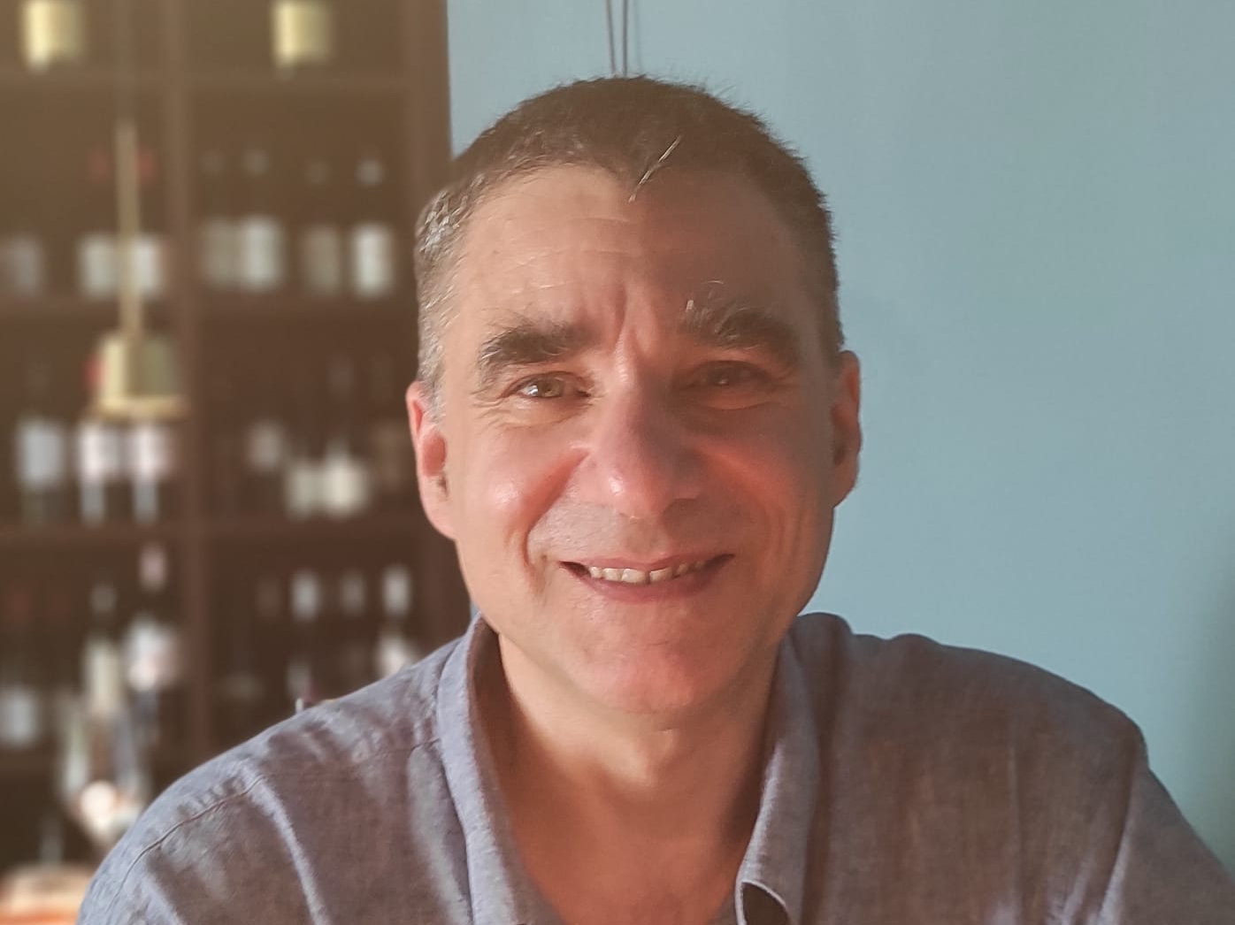
Personal information
First name(s) / Surname(s) |  | Federico Fogolari
Address |  | Universita’ degli studi di Udine  Dipartimento di Matematica, Informatica e Fisica  Via delle Scienze 206, 33100 Udine  Italy
Telephone |  | ++39 0432 558493
E-mail |  | ( federico.fogolari@uniud.it )
Date of birth |  | May 7, 1963
Education
1982– 1988
Università di Trieste |  | Laurea in Fisica
1988 – 1990
Scuola Internazionale di Studi Superiori Avanzati |  | Magister Philosophiae
1991-1992
Scuola Internazionale di Studi Superiori Avanzati |  | Philosophiae Doctor
Work experience
Dates |  | 11/2004 - now
University of Udine
SSD  Role |  | FIS/07  Associate professor (Assistant professor 2004)
Dates |  | 4/1997 - 10/2004
University of Verona
SSD  Role |  | CHIM/06  Assistant professor
Dates |  | 2/1991 - 3/1997
University of Udine
SSD  Role |  | E10X (Biophysics, now FIS/07)  Technician (“tecnico laureato”)
Research experience
Dates |  | 1990 - 2018
 |  | Biophysics Laboratory, University of Udine (profs. G. Esposito, P. Viglino)
Dates |  | 7/2007
 |  | visiting scholar at the University of Utrecht (The Netherlands) in the laboratory of prof. A. Bonvin.
Dates |  | 1997-2004
 |  | Organic Chemistry Laboratory, University of Verona (prof. H. Molinari)
Dates |  | 10/1995 - 9/1996
 |  | University of California at San Diego in the research group of prof. McCammon, supported by a NATO fellowship.
Dates |  | 5/1992 - 8/1992
 |  | European Molecular Biology Laboratory, (EMBL) Heidelberg (Germany), in the group of A. Pastore, supported by a short term EMBO fellowship.
Dates |  | 11/1989 - 6/1990
 |  | Biophysical Chemistry Laboratory of the University of Nijmegen (The Netherlands) (group of prof. van de Ven, director prof. C. W. Hilbers)
Self-assessment |  |  | Understanding |  |  |  |  | Speaking |  |  |  |  | Writing
European level (*) |  |  | Listening |  | Reading |  |  | Spoken interaction |  | Spoken production
Language |  |  |  | good |  | good |  |  | good |  |  | good |  | good
 |  | (*) Common European Framework of Reference for Languages
University teaching |  | Physics, Applied bioinformatics, Biopolymers, Biological physical chemistry, Principles of drug design. Quantum computing and communication
Institutional positions held in university |  | 10/1997 - 10/2004 Member of the faculty of PhD course in Biotechnology in the University of Verona  11/2006-10/2015 Member of the faculty of PhD courses in Biomedical and Biotechnological Sciences of the University Udine.  11/2014 – 3/2016 Chair of the master degree in Sanitary Biotechnologies, University of Udine.  11/2016-now Member of the faculty of PhD course in Mathematics and Physics (formerly, up to 2020, Mathematics Informatics and Physics) of the University Udine.  2021-now Deputy coordinator of the PhD course in Mathematics and Physics of the University Udine.
Scientific publications |  | As of April 2023, author of more than 150 publications indexed in ISI.  The update list can be found at URL:  https://scholar.google.com/citations?user=YixfQEUAAAAJ  As of April 2023, more than 7000 citations and H-index = 42  Author of 8 structures in the Protein Data Bank
Research projects and/or groups |  | Electrostatics in biomolecular and nanoscale systems  Computer simulations of biomolecules  Structural Bioinformatics  Entropy calculations in biomolecular systems  Impact of mutations on the stability and recognition of biomolecules

I authorize the processing of my personal data in accordance with Article 13 of Legislative Decree No. 196 of June 30, 2003 –
“Code regarding the protection of personal data" and Article 13 of the GDPR 679/16 –
“European Regulation on the protection of personal data”

